UNIT I

Introduction to Computers: Creating and running Programs, Computer Numbering System, Storing Integers, Storing Real Numbers
Introduction to the C Language: Background, C Programs, Identifiers, Types, Variable, Constants, Input/output, Programming Examples, Scope, Storage Classes and Type Qualifiers
Structure of a C Program: Expressions Precedence and Associativity, Side Effects, Evaluating Expressions, Type Conversion Statements, Simple Programs, Command Line Arguments

Introduction to Computers

Computer:
- Computer is an electronic device which takes input data, process that data and gives desired output to the user.
- Charles Babbage is called as father of computer.
- We use computers to get accurate results and fast results.

Computer Systems:
- A computer system is made up of two components. They are software and hardware.
- The computer hardware is physical components.
- The computer software is collection of programs(instructions) that allow the hardware to do its job.
- The following figure represents a computer system.

Computer hardware:
- The hardware components of the computer system consist of 5 parts.
- They are input devices, Central Processing Unit (CPU), primary storage, auxiliary storage and output devices.
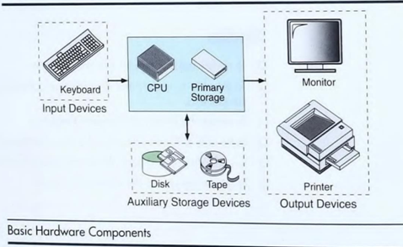
- The input device is usually a keyboard where programs and data are entered into the computer. Examples of other input devices are mouse, a pen or stylus, a touchscreen or an audio input unit.
- The Central Processing Unit (CPU) is responsible for executing instructions such as arithmetic calculations, comparisons among data, movement of data inside the system. Todays computers have one, two or more CPU’s.
- Primary Storage, is also known as main memory, is a place where the programs and data are temporarily stored during processing. The data in the primary storage is erased when we turnoff a computer.
- Auxiliary storage, is also known as secondary storage, is used for both input and output. In this storage both programs and data stored permanently. Even when we turn off the computer also data remain in the secondary storage.
- Output device is usually a monitor or a printer to show output. If the output is shown on the monitor it is called soft copy and if it is printed on the printer, we say it is as a hard copy.

Computer software:
- Computer software is divided into two broad categories. They are System Software and Application Software.
- System software manages the computer resources. It provides the interface between hardware & the user and but does nothing to directly serve the user’s needs.
- Application software on the other hand is directly responsible for helping users to solve their problems. The following figure shows the breakdown of computer software.
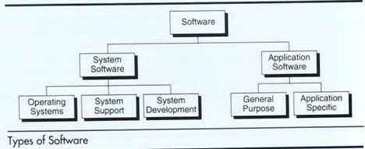

System Software:
- It consists of programs that manage the hardware resources of a computer and perform required information processing tasks.
- These programs are divided into 3 classes. The Operating Systems, System Support and System Development.
- The Operating System provides services such as a user interface, file and database access, and interfaces to communication systems such as internet protocols.
- The primary purpose of this software is to keep the system operating in an efficient manner while allowing the users access to the system.
- System Support Software provides System Utilities and other Operating Services. Examples of system utilities are sort programs and disk format programs. Operating services consist of programs that provide performance statistics of the operational staff and security monitors to protect the system and data.
- System Development Software, includes language translators that convert into machine language for execution.

Application Software:
- It is broken into 2 classes. General purpose software and application specific software.
- General purpose software is purchased from a software developer and can be used for more than one application. Examples are word processor, database Management systems and Computer aided design systems.
- Application specific software is used for only its intended purpose. A general ledger system used by accountant and a material requirement planning system used by manufacturing organization are examples.
The relationship between system software and application software can be shown below.
- In the diagram each circle represents an interface point.
- To work with a system, user uses an application software.
- The application software interacts with the operating system which is part of the system software layer.
- The system software provides the direct interaction with the hardware.

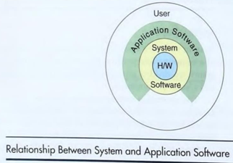

Computing Environment
- It is a collection of computers / machines, software, and networks that support the processing and exchange of electronic information meant to support various types of computing solutions.
Types of Computing Environments:-
  - Personal Computing Environment
  - Time sharing Environment
  - Client Server Computing Environment
  - Distributed Computing

Personal Computing Environment:-
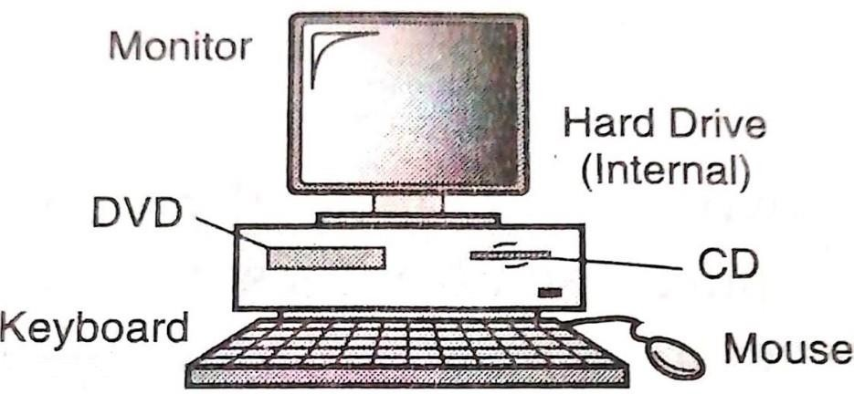
- Personal (general-purpose) means, all the computer stuff will be tied together i.e computer is completely ours, no other Connections. Size in small.

2. Time sharing Environment:-
- Many users are connected to one or more computers. These computers may be mini or mainframe computers.
- In time-sharing environment, the output devices and secondary storage devices are shared by all of the users by means of multi programming and multi-tasking.
- All computing must be done by the central computer. The central computer must manage shared data and printing; and it must do the computing.
- It keeps the computer busy that the users become frustrated with the slow responses.
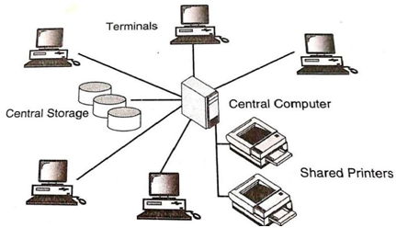

3. Client Server Computing Environment:-
- A client/server system is a “networked computing model that distributes process between clients and servers, which supply the requested service”.
- A client/server network connects many computers, called clients to a main computer called servers.
- Whenever a client requests for something, server receives the requests and process it.
- As the work is shared between the users computers and the central computer, the reponse time is fast.
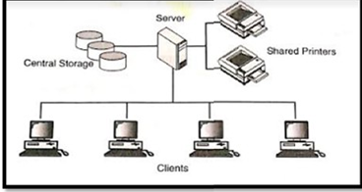
4. Distributed computing Environment:-
- A distributed computing environment provides a integration of computing functions between different serves and clients.
- The internet provides connectivity to different serves throughout the world.
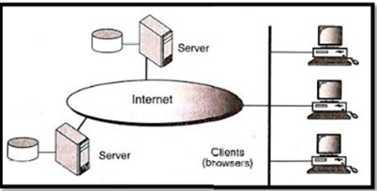

Computer Languages Classification
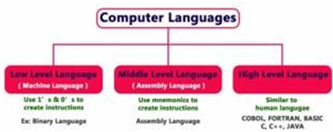
- Computer languages have been evolved from Low Level to High Level Languages. In the earliest days of computers, only Binary Language was used to write programs.
- The computer languages are classified as follows...

Low Level Language (Machine Language)
- Low Level language is the only language which can be understood by the computer. . Low level language is also known as Machine Language. Binary Language is an example of low level language.
- The binary language contains only two symbols 1 & 0. All the instructions of binary language are written in the form of binary numbers 1's & 0's.
- As the CPU directly understands the binary language instructions, it does not require any translator.
- CPU directly starts executing the binary language instructions, and takes very less time to execute the instructions as it does not requires any translation. Low level language is considered as the First Generation Language (FGL)
Advantages
- A computer can easily understand the low level language.
- Low level language instructions are executed directly without any translation.
- Low level language instructions require very less time for their execution.

Disadvantages
- Low level language instructions are very difficult to use and understand.
- Low level language instructions are machine dependent, that means a program written for particular machine does not executes on other machine.
- In low level language, there is more chance for errors and it is very difficult to find errors, debug and modify.
Middle Level Language (Assembly Language)
- Middle level language is a computer language in which the instructions are created using symbols such as letters, digits and special characters. Assembly language is an example of middle level language.
- In assembly language, we use predefined words called mnemonics. Binary code instructions in low level language are replaced with mnemonics and operands in middle level language.
- But computer cannot understand mnemonics, so we use a translator called Assembler to translate mnemonics into binary language.
Advantages
- Writing instructions in middle level language is easier than writing instructions in low level language.
- Middle level language is more readable compared to low level language.
- Easy to understand, find errors and modify.
Disadvantages
- Middle level language is specific to a particular machine architecture that means it is machine dependent.
- Middle level language needs to be translated into low level language.
- Middle level language executes slower compared to low level language.

High Level Language
- High level language is a computer language which can be understood by the users.
- High level language is very similar to the human languages and have a set of grammar rules that are used to make instructions more easily.
- Every high level language have a set of predefined words known as Keywords and a set of rules known as Syntax to create instructions.
- High level language needs to be converted into low level language to make it understandable by the computer. We use Compiler or interpretor to convert high level language to low level language.
- Languages like COBOL, FORTRAN, BASIC, C ,C++, JAVA etc., are the examples of high level languages.
Advantages
- Writing instructions in high level language is more easier.
- High level language is more readable and understandable.
- The programs created using high level language runs on different machines with little change or no change.
- Easy to understand, create programs, find errors and modify.
Disadvantages
- High level language needs to be translated to low level language.
- High level language executes slower compared to middle and low level languages

Compiler | Interpreter
Compiler Takes Entire program as input | Interpreter Takes Single instruction as input
Intermediate Object Code is Generated | No Intermediate Object Code is Generated
Conditional Control Statements executes  faster | Conditional Control Statements executes  slower
Memory Requirement: More (Since Object Code is Generated) | Memory Requirement is Less
Program need not be compiled every time | Every time higher level program is converted into lower level program
Errors are displayed after entire program is checked | Errors are displayed for every instruction  interpreted (if any)
Example: C Compiler | Example: BASIC

Understanding Computer Languages
The following figure provides few key points related to the computer languages.
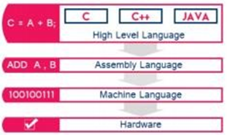
From the above figure, we can observe the following key points...
- The programming languages like C, C++, Java etc., are written in High level language which is more comfortable for the developers.
- High level language is more closer to the users.

Creating and running programs
We have 4 steps to convert a program in high-level language into Machine language.
- Writing and editing the program.
- Compiling the program.
- Linking the program with the required library modules and
- Executing the program.

Writing and editing programs:
- The software used to write and edit programs is known as text editor.
- The text editor could be widely applicable is word processor, it is more special editor with compiler because these editors have some features like copy, paste of code from one place to another place in the program and can perform align the statements with tabs.
- After we complete the program save the file to the disk. This file will be given input to the compiler. This file is called source file.

Compiling Programs:

The code in the source file to be converted into machine language, it is done by compiler.
- The C compiler is 2 separate programs. They are preprocessor and translator.
- Preprocessor reads the preprocessor commands. These commands tell the preprocessor to look for the special code libraries and make substitutions into the code. The result of preprocessing is called the translation unit.

After preprocessor has prepared the code the translator converts the code into machine language.

The translator reads the translation unit and writes the resulting object module to a file. Even though the output of the compiler is machine language it is not completed to be executed.

Linking programs:

C program is made up of many functions. These functions are like input/output processes, mathematical library functions, etc.

The linker assembles all these functions into final executable program.

Executing Programs:

Once our program is linked it is ready for execution. To execute a program, , we use Operating System command such as run to load the program into main memory..

Getting the program into main memory is the function of the operating system program is known as loader. When the program is loaded execution takes place.

In today’s integrated environment all these processes are done in a single click or one pull down window.

The program takes the input from a file or from the user. After processing/ execution is done output is displayed on the monitor or stored in a file.

When the program has finished its job, it tells the operating system which then removes the program from the memory.

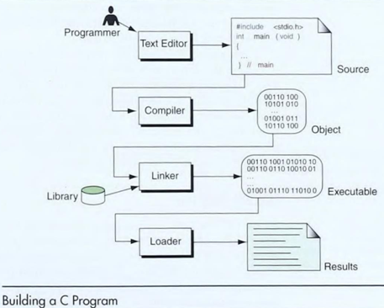

Computer Numbering System

Computer science uses several number systems. They are binary number system, decimal number system, octal number systems, hexa decimal number system and base 256 system.

Decimal Number systems:

The word decimal is derived from the Latin stem Deci meaning ten. The decimal number system uses 10 symbols. they are 0,1,2,3,4,5,6,7,8, and 9.

The decimal number 14782.721 has eight digits in positions -3 to 4.

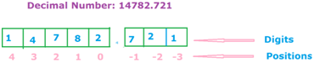

Weights

Weight is 10 raised to the power of its position. The weight of the symbol at position -1 is 10-1 (1/10).

The weight of the symbol at position 0 is 100 (1) and the weight of the symbol at position 1 is 101 (10) etc.

Binary Numbers (Base 2):
- The binary system uses two symbols. 0 and 1. The word binary derives from the Latin stem bi, meaning two.

Weights

Weight is 2 raised to the power of its position.

The weight of the symbol at position -1 is 2-1 (1/2) while the weight of the symbol at position 0 is 20 (1) and the weight of the symbol at position 1 is 21 (2) etc.

Binary to decimal Conversion:

Weights are used to convert binary to decimal.

Multiply each digit by its weight and add all the weighted results.

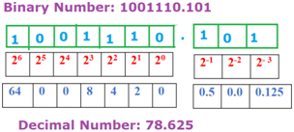

Storing Integers:
- Data are stored in the computer in binary. Numbers must be changed to base 2 to be stored in computer.
Unsigned Integers
- Storing unsigned integers is a straightforward process. The number is changed to the corresponding binary form, and the binary representation is stored.
- For example, an unsigned binary integer can be stored as a number from 0 to 15 as shown in the following figure.
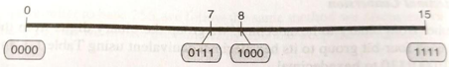
Unsigned Integer

Signed Integers
- Storing signed integers is different from storing unsigned integers because we must consider both positive and negative numbers.
- Four methods are designed to store signed integers in a computer:
  - Sign and magnitude
  - one’s complement
  - two’s complement
  - excess system

Sign and magnitude -

In sign and magnitude, we divide the available range between the positive and negative numbers.

The Lower part of the range occupies the positive numbers; the upper part occupies the negative numbers.

Consider the leftmost bit to represent the sign of the number and the rest of the bit to be the absolute value, the magnitude of the number.
- Let us see how a 4-bit integer can both hold the positive and negative numbers.
- The following figure shows the partition of the range between positive and negative numbers.
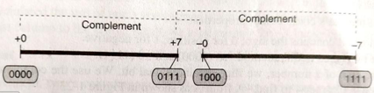
Signed Integer Format

Sign and magnitude Properties:
- The left most bit contains the sign of the number 0 for positive and 1 for negative.
- There are two zeros in this method: +0 (0000) and -0 (1000)
- Addition and subtraction are very inefficient operations.
- To change the sign of the number we need to flip only first bit.
Applications
- The sign and magnitude method, is used in computer science when we do not need mathematical operations.
- One of these areas is storing analog and digital signals.
One’s complement -
- One’s complement is similar to sign and magnitude; however the partition of the range between the positive and negative numbers is different.
- A positive and negative number are symmetric with respect to the middle of the range.
- The following figure shows the positive and negative numbers are distributed.
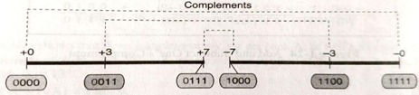
One’s complement format
One’s complement properties
- The left most bit contains the sign of the number 0 for positive and 1 for negative.
- There are two zeros in this method: +0 (0000) and -0 (1000)
- To flip the sign of a number, we flip each individual digit. We use complement operator (~)
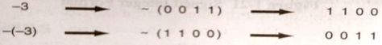
Flipping signs in One’s complement
- Addition and subtractions are very simple operations. Only thing we need to consider about adding and subtracting is to add the carry produced at the last column to the result.
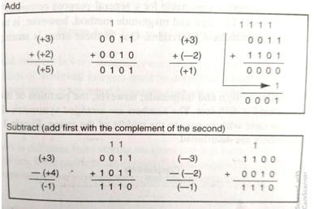
Add and Subtract One’s Complement
Applications
- Early general-purpose computers, such as VAX used one’s complement form.
- Modern general- purpose computers do not use this. We use this in the checksum calculation.

Two’s complement -
- Twos complement also shares the range between positive and negative numbers.
- The partition of the range between the positive and negative numbers is different.
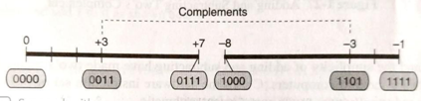
Two’s complement format
Two’s complement properties
- The left most bit contains the sign of the number 0 for positive and 1 for negative.
- There is one zero in this method: 0 (0000).
- To change the sign of a number we need two operations. First, we flip each individual bit, then we need to add 1 to the previous result.
- Addition and subtraction are simpler.
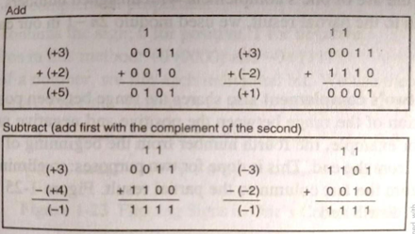
Add and Subtract Two’s Complement
Applications
- C uses the hardware instruction set of the computers it runs on which almost universally uses two’s complement arithmetic.

Excess:

Overflow
- Overflow occurs because integers are stored on a limited size word in the computer.
- For example, if the size of the integer is 4 bits, we can either store an unsigned integer between 0-15 or a signed integer between -8 to +7. Any number beyond this range overflows.
- In these cases computer doesn’t give any error or warning simply it drop/truncates the extra bit/bits which are not fit in the allocated space.
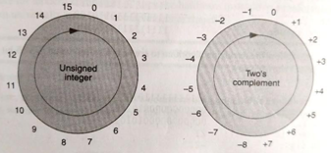
Range of Integer Values

Storing real numbers
- The scientific notation are represented using a real number, we can show a real number such as -314.625 as -3.14625 x 10 +2.
- A real number is made of the sign, precision and the power of ten. If we write the number in binary system -10011. 10101010 x 2100.

Normalization:
- We have one problem with the position of the binary point. We can store only binary digits not a point.
- The solution is normalization. We normalize the number so that the point is always at a fixed position.

Sign, Exponent and Mantissa

Sign
- The sign of the number is stored using one bit (0 for plus and 1 for minus)

Exponent
- The exponent (power of 2) defines the power. Note that the power can be negative or positive.
- Excess is the method used to store the exponent.

Mantissa
- The mantissa is the binary number to the right of the binary of the binary point.
- It defines the precision of the number. The mantissa is stored as an integer.

IEEE Standards
- The Institute and Electronics Engineers (IEEE) has defined two standards to store numbers in memory (single and double precision). These formats are shown below.
- Note that the number inside the boxes is the number of bits for each field.
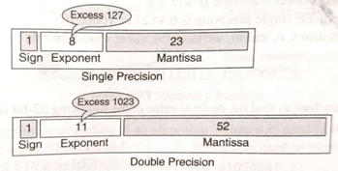

IEEE Standards for Floating Point Representation

Introduction to the C Language

Background

C is a Structured Programming Language. C is derived from ALGOL, the first language to use a block structure.

In 1967, Martin Richards developed a language called Basic Combined programming language (BCPL).

Ken Thompson followed in 1970 with a similar language called B. B was used to develop the first version of UNIX.

Dennis Ritchie developed C which took many concepts from ALGOL, BCPL.

In 1972 first version is release. but got popular with the book by Brian W. Kernighan and Dennis Ritchie in 1978

In 1983, the American National standards Institute (ANSI) started certifying the standard C. It was approved in the Dec-1989.

In 1990, the International Standards Organization (ISO) adopted the ANSI standard. This version of C is known as C89.

In 1995, minor changes were made to the standard. This version is known as C95.

A much more significant update was made in 1999. The changes incorporated into the standard, now known as C99 are summarized in the following list.
  - Extensions to the character type to support non-English characters.
  - A Boolean type
  - Extensions to the integer type
  - Inclusion of type definitions in the for statement.
  - Addition of imaginary and complex types
  - Incorporation off the C++ style line comment (///)

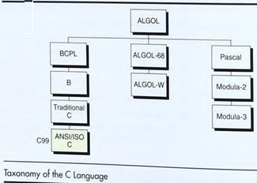

C Programs
This section discusses basic parts of a C program

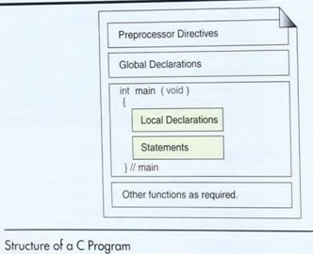

Structure of a C program

Every C program is made of one or more preprocessor commands, a global declaration section, and one or more functions.

The global declaration section comes at the beginning of the program. The basic idea of global declarations is that they are visible to all the parts of the program.

The work of the program is carried out by its functions, blocks of code that accomplish a task within a program. one and only one of the functions must be named main.

The main function is the starting point for the program. All functions including main are divided into 2 section.

one is declaration section and

other is statements section.

The declaration section is at the beginning of the function. It describes the data that we will be declarations in a function are known as local declarations. Because they are visible only to the function that contains them.

The statements section follows the declaration section. It contains the instructions to the computer that cause it to do something, such as add two numbers.

Preprocessor commands are special instructions they tell it how to prepare a program for compilation.

One of the most important of the preprocessor commands, and one that is used in virtually all programs is include.

The include command tells the preprocessor that we need information from selected libraries known as header files. We need to use at least one header file to run our program.

Your first C Program

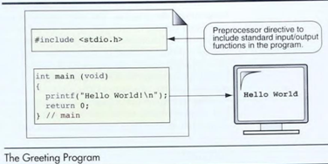

Our first C program is very simple. it has only one preprocessor command, no global declarations, and no local definitions. Its purpose will be simply to print a greeting to the user.

So, the statements section had only 2 statements. one that prints a greeting and one that stops the program.

Preprocessor commands:

Preprocessor commands come at the beginning of the program. All preprocessor commands start with a pound sign (#).

The preprocessor command tells the compiler to include the standard input/output library file in the program.

We need this library file to print a message to the terminal. Printing is one of the input/output processes identified in this library.

The complete syntax for this command is shown below.

#include <stdio.h>

A preprocessor command it must start with a pound symbol, there can be no space between the pound sign and the keyword

include. it tells the preprocessor that we want the library include, it tells the preprocessor that we want the library

The name of the header file is stdio.h, the abbreviation is standard input/ output header file.

main():

The executable part of our program begins with the function main, which is identified by the function header.

In the main function int says that the function will return an integer value to the OS, that the functions name is main, and it has no parameters (the parameters list is void).

int main(void)

Within main there are 2 statements.

one to print the message and

one to terminate the program.

The print statement uses a library function to execute this print function, printf, followed by a parameters list enclosed in parentheses.

For example, whatever we want to display we place that in two double quote marks (".."). the \n at the end of the message tells the computer to advance to the next line in the output.

The last statement in our program, return 0, terminates the program and returns control to the OS.

Comments

It is helpful if the person who writes the code places some comments in the code to help the reader.

The compiler ignores these comments when it translates the program into executable code.

To identify a comment, two different formats: block comments, line comments

Block Comments:

A block comment is used when the comment have several lines, we call this comment format block comment it uses opening and closing comment tokens.

A token is one or more symbols understood by the compiler that help it interpret code, each comment token is made of 2 characters. There can be no space between them the opening token is /* and the closing token is */.

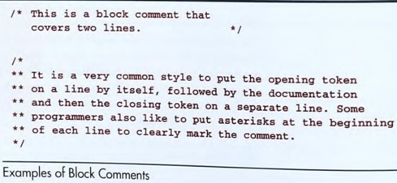

Line Comment:

Comment can appear anywhere, comments cannot be nested i.e., we cannot have comments inside comments.

Once the compiler sees an opening block-comment token, it ignores everything it sees until it finds the closing token.

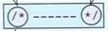

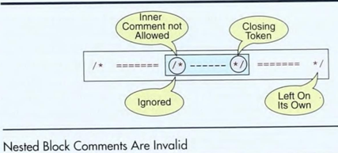

Program
/* The greeting program. This program demonstrates some of the components of a simple C program. Written by: your name Date: date*/
#include<stdio.h>
int main(void)
{
// Local Declarations
// Statements
printf(“Hello World\n”);
return 0;
}// main

Identifiers

Identifiers allow us to name data and other objects in the program. Each identified object in the program is stored at a unique address.

In C the rules for identifiers are:

The only valid name symbols are the capital letters A through Z, the lowercase letters a through z, the digits 0 through 9 and the underscore.

The first character of the identifier cannot be a digit, can start with underscore.

Name we create cannot be keywords. Keywords also known as Reserved Words.

Good identifier names are descriptive and short.

C allows names to be up to 63 characters long. If the names are longer that length, system considers only 63 characters.
Valid names | Invalid names
a // valid but poor style | $sum //$ is illegal
student_name | 2names // first char digit
_astudentName | aum-salary // contains hyphen
_Bool // Boolean system id | stdnt Nmbr // contains spaces
INT_MIN // System Defined Value | int // Keyword

Keywords

Definition:

Keywords are the system defined identifiers (reserved identifiers) and cannot be as the names of the program variables or other user defined program elements (user defined function names).
- All keywords have fixed meanings that do not change.
- White spaces are not allowed in keywords.
- Keyword may not be used as an identifier.
- It is strongly recommended that keywords should be in lower case letters.
- There are totally 32(Thirty-Two) keywords used in a C programming.
int | float | double | long | short | signed | unsigned | const
if | else | switch | break | default | do | while | for
register | extern | static | struct | typedef | enum | return | sizeof
goto | union | auto | case | void | char | continue | volatile

Types
- A type defines a set of values and a set of operations that can be applied on those values.
- C language has defined a set of types that can be divided into four general categories. void, integral, floating-point, and derived as shown in the figure.
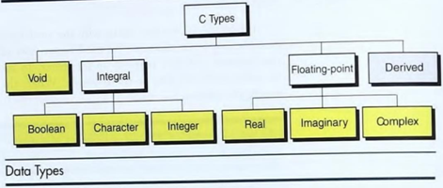

Void type:
- The void type, used with the keyword void, has no values and no operations. Void is very much useful in functions.
- For example, if we don’t want to return any value from the function and if a function doesn’t take any parameters in these cases void type is used.

Integral Type:
- The C language has 3 integral types: Boolean, character and integer.
- Integral types cannot contain a fraction part; they are whole numbers

Boolean

The release of C99, the C language incorporated a Boolean type.

A Boolean type can represent only two values; true or false.

C used integers to represent the Boolean values: A nonzero number (positive or negative) was used to represent true and zero was used to represent false.

The Boolean type, which is referred to by the keyword bool, is stored in memory as 0 (false) or 1 (true).

Character

A character is any value that can be represented in the computer alphabet, or it is known as character set.

C standard provides two-character types; char and wchar_t.

Most of the computers use 1 byte to store the char data type. a byte is 8 bits.

Although the size of char is machine dependent and varies from computer to computer, normally it is 1 byte, or 8 bits.

In the computer, value of the bit configuration for the letter a is binary 0110 0001, the letter x is 0111 1000 the decimal values of these two binary numbers are 97 and 120 respectively.

Most computers use the American Standard code for information interchange alphabet.

Integer:

An integer type is a number without a fraction part.

C supports 4 different sizes of the integer type. short int, int, long int and long long int.

The sizes of these types are machine dependent which varies from computer to computer. C provides an operator sizeof that tells us the exact size in bytes.

Each integer size can be a signed or an unsigned integer.

If the integer is signed, then one bit must be used for a signed (0 is plus, 1 is minus).

The unsigned integer can store a positive number that is twice The unsigned integer can store a positive number that is twice.

Type | Byte size | Format specifier | Minimum value | Maximum value
Short int | 2 bytes | %hd | -32,768 | 32767
Int | 4 bytes | %d | -2,147,483,648 | -2,147,483,647
Long int | 4 bytes | %ld | -2,147,483,648 | -2,147,483,647
Long long int | 8 bytes | %Ld | -9,223,372,036,  854, 775, 807 | 9,223,372, 036, 854,  775, 806

Floating-point types:
- The C standard recognizes 3 floating point types: real, imaginary, and complex.

Real:
- The real type holds values that consist of an integral part and a fraction part, such as 3.14.
- The C language supports 3 different sizes of real types: float, double, and long double.
Type | Storage size | Format specifier | Value range | Precision
float | 4 bytes | %f | 1.2E-38 to 3.4E+38 | 6 decimal places
double | 8 bytes | %lf | 2.3E-308 to 1.7E+308 | 15 decimal places
long double | 10 bytes | %Lf | 3.4E-4932 to 1.1E+4932 | 19 decimal places

Imaginary type:
- An imaginary number is a real number multiplied by the square root of -1.
- The imaginary type like the real type can be of three different sizes: float imaginary, double imaginary and long double imaginary.
- Most C implementations do not support the imaginary type yet and the functions to handle them are not part of the standard.

Complex:
- A complex number is a combination of real and imaginary number. The complex type like the real type can be of three different sizes: float complex, double complex, and long long complex.
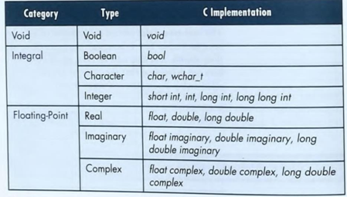
Variables
- Variables are named memory locations that have a type, such as integer or character.
- The type determines the values that a variable may contain.
Variable Declaration
- Each variable in a program must be declare and defined. In C, a declaration is used to name an object, such as a variable.
- A variable can declared and defined at the same time & a variable is declaring them first and then defines them at a later time.
- When we create variables, the declaration gives a symbolic name and the definition reserves the memory.
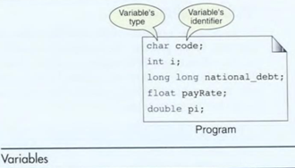
- A variable's type can be any of the data types such as a character, integer or real but it should not be of type void.
- To create a variable, we first specify its type which automatically specifies the size. for example,

float price;
- The following table shows some examples of declarations and definitions. C allows multiple variables of the same type to be defined in one statement.
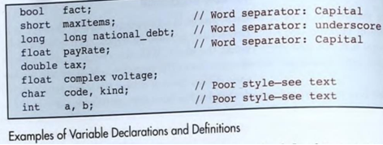
Variable initialization
- We can initialize a variable at the same time that we declare.
- To initialize a variable when it is defined, the identifier is followed by the assignment operator (=) and the initializer, which is the value the variable is to have.
int count = 0;
int sum, count=0;
- Some examples are shown in the following table
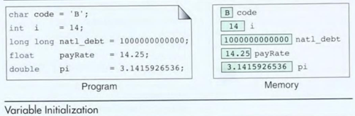
- When variables are defined, they usually contain garbage (meaningless values left over from a previous use). So, we need to initialize them.
- Many compilers display a warning message when a variable is accessed before it is initialized.

Difference between identifier and variable
- The identifier is only used to identify an entity uniquely in a program at the time of execution whereas, a variable is a name given to a memory location that is used to hold a value.
- Variable is only a kind of identifier, other kinds of identifiers are function names, class names, structure names, etc.
Constants
- Constants are data values that cannot be changed during the execution of a program. Like variables, constants have a type.
Boolean Constants
- A Boolean data type can take only 2 values. The values are true and false.
- When we use the Boolean constant must include the Boolean library, stdbool.h.
Example: output:
#include <stdio.h> x is false.

#include <stdbool.h>
int main()
{
Bool x = false;
if(x== true)
printf("x is true.");
else
printf("x is false.");
return 0;
}
Character Constants
- Character constants are enclosed between two single quotes (apostrophes).
- In addition to the character, we can also use a backslash (\) before character. The backslash is known as the escape character.
- The escape character says that what follows is not the normal character but something else (line feed).
- For example, '\n' represents the new line character.

Example: char c=’a’;
char c=’5’;

ASCII character | Symbolic name | ASCII character | Symbolic name
Null character | ‘\0’ | Form feed | ‘\f’
Alert (bell) | ‘\a’ | Carriage return | ‘\r’
Backspace | ‘\b’ | Single quote | ‘\’’
Horizontal tab | ‘\t’ | Double quote | ‘\”’
New line | ‘\n’ | Backslash | ‘\\’
Vertical tab | ‘\v’
Integer constants
- A constant of integer type consists of a sequence of digits.
- For example: 1,34,567,8907 are valid integer constants.
Rules
- It consist minimum of 1 digit, it does not contain a decimal point (2).
- Integer value may be ‘+ve’ and ‘-ve’ even ‘0’ these are also considered as integer.
- For example 400, +786, -10 etc.
Real Constants
- The default form for real constants is double.
- f and F are used for float and l and L are used for long double.
Complex constants
- Complex constants are coded as two parts, the real part and the imaginary part, separated by a plus sign.
- The real part is coded using the real format rules and the imaginary part is coded as a real number times (*) the imaginary constant (_complex_I).
- If the complex library (complex.h) is included, the imaginary constant can be abbreviated as I.
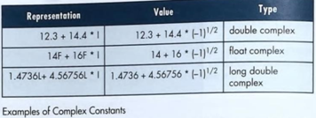

String constants
- A string constant is a sequence of zero or more characters enclosed in double quotes. The following table gives string constants.
- The first example is an empty string is simply two double quotes in succession.
- The second example, string containing only the letter h, differs from a character constant in that it is enclosed in double quotes.
- The last example that string uses wide characters.
“” // a null string “h”
“computer”
L “wide characters”
- The basic difference between the null character and an empty string is null character represents no value, and an empty string on the other hand is a string containing nothing.
- The following figure shows the difference between two constant types.
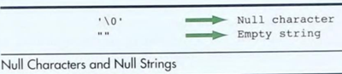
Coding Constants
3 different ways to use coding constants in our programs. They are literal constants, defined constants and memory constants.
Literal Constants
- A literal is unnamed constant used to specify data.
- If we know that the data cannot be changed, then we can simply code the data value itself in a statement.
- For example, the literal 5 is used in the following statement.

a=b +5;
Defined constants
- Another way to designate a constant is to use the preprocessor command define.
- The define commands are usually placed at the beginning of the program. An example command might be
#define SALES_TAX_RATE
.825 Memory constants
Memory constants use a C type qualifier, const, to indicate that the data cannot be changed. Its format is
const type identifer = value; const float pi=3.1215;
Input/output
Streams
- A Stream is a source of or destination for data. It is associated with a physical device, such as a terminal, or with a file stored in auxiliary memory.
- C uses two forms of streams: text and binary. A text stream consists of a sequence of characters divided into lines with each line terminated by a newline (\n).
- A binary stream consists of a sequence of data values such as integer, real or complex.
- A terminal can be associated only with a text stream because a keyboard can only send a stream of characters into a program and a monitor can only display a sequence of characters.
- A file, on the other hand can be associated with a text or binary stream.
Formatting input/ output
- The C language provides 2 formatting functions: printf for output formatting and scanf for input formatting.
- The printf function converts data stored in the program into a text stream for output to the monitor.
- The scanf function converts the text stream coming from the keyboard to data values and stores them in program variables.

Output formatting: printf
- The printf function takes a set of data values, converts them to a text stream using formatting instructions contained in a format control string, and sends the resulting text stream to the standard output (monitor).
- For example, an integer 234 stored in the program is converted to a text stream of three numeric ASCII characters ('2','3'.'4') and then is sent to the monitor.
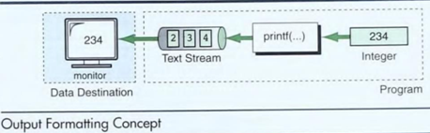
Syntax:
printf(“Format control string”, data_value1, data_value2, . . . , data_valuen);
Control String
- Format Specifier given in the form of % specifier.
- Escape sequence characters such as \n (new line) \t(tab).
- It can have a string that must be printed on the monitor.
- The format of numbers displayed by printf() can be controlled by field with specifiers included as part of each conversion control sequence.
printf(“sum of %.3d and %4d is %5d”,6,15,21);
Output: sum of ∧∧6 and ∧∧∧5 is ∧∧∧21
Example program using field width in print statement
#include<stdio.h> output:
int main() ∧∧6
{ ∧18
printf(“\n%3d”,6); 124
printf(“\n%3d”,18); ----
printf(“\n%3d”,124); 148
printf(“\n ----“);
printf(“\n%3d”,6+18+124);
return 0;
}
Float point
%5.2f – 42.30
%5.2f – 142.36
%10.3f – ∧∧∧∧25.670
Format Modifier (modifiers for printf formats)
- A format specification can also include “modifiers” that can control how much of the item’s values is printed and how much space it gets.
- The modifiers come between the % and the format control letter.
Justification
- It controls the placement of a value when it is shorter than the specified width.
- Justification can be left or right. The format modifier (-) minus is used.
Left Justification
- A format specification has (-) minus sign used before the width modifier says to left justify the argument within its specified width.
Example: printf(“%-10d”,59);
Output: 59∧∧∧∧∧∧∧∧
Right Justification + format modifier (or) explicit sign display
- The positive sign is used before the width modifier, says to right justify the argument with its specified width.
Example: printf(“%+10d”,59);
Output: ∧∧∧∧∧∧∧∧59
printf() using left and right justification
#include<stdio.h> output:
int main() right
{ left
printf(“%+10s\n”,”right”); abcd
printf(“%-10s\n”,”left”); abcd
printf(“%+10s\n”,”abcd”);
printf(“%-10s\n”,”abcd”);
return 0;
}

Input formatting: scanf
- This function takes a text stream from the keyboard, extracts and formats data from the stream according to a format control string, and then stores the data in specified program variables.
- For example, the stream of 5 characters '2’, '3', '4', '.', and ‘2’ are extracted as the real 234.2 the following figure shows the concept.
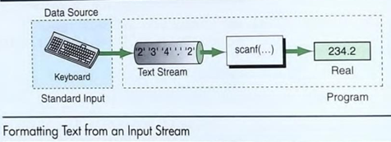
Syntax: scanf(“control string”, address list);
Example: scanf (“%d % f “, &x, &y);
Control string
- It tells the function the type of data being Input and uses the same control sequences as the printf() function.
- It enclosed with double quotes (“ “).
- It specifies the type of values that have to be read from keyboard. Control string consists of format specification.
Example:
Integer - %d Float - %f double - %lf long double - %Lf char - %c
Addresses list
- It contain addresses of i/o variables proceed the addresses are specified by before the variable by ampersand (&) operator.
Scope (Variable Scope (or) visibility)
- Scope determines the region of the program in which a defined object is visible- that is, the part of the program in which we can use the objects name.
- Scope relates to objects like variables or function names. There are 4 types are scopes
  - Global (or) Program Scope
  - Block (or) Local Scope
  - Function Scope
  - File Scope
Global (or) Program Scope
- Any object defined in the global area of a program is visible from its definition to end of the program.
- In the below program function declaration fun is global declaration. It is visible everywhere in the program.
- Life time of the global variables is through out the program.
Block (or) Local Scope
- If a variable is declared within the curly brackets ({ }) are called local variables
Function Scope
- Function scope can only be referred inside a function body.
- If the variable used in the function that variable is not used in other functions or not used anywhere in the program.
File Scope
- When a global variable is accessible until the end of the file the variable is said to have file scope.
- To allow a variable to have file scope declare the variable with the static keyword before specifying its data type.
static int x=10;
- A static global variable can be used anywhere in the file.
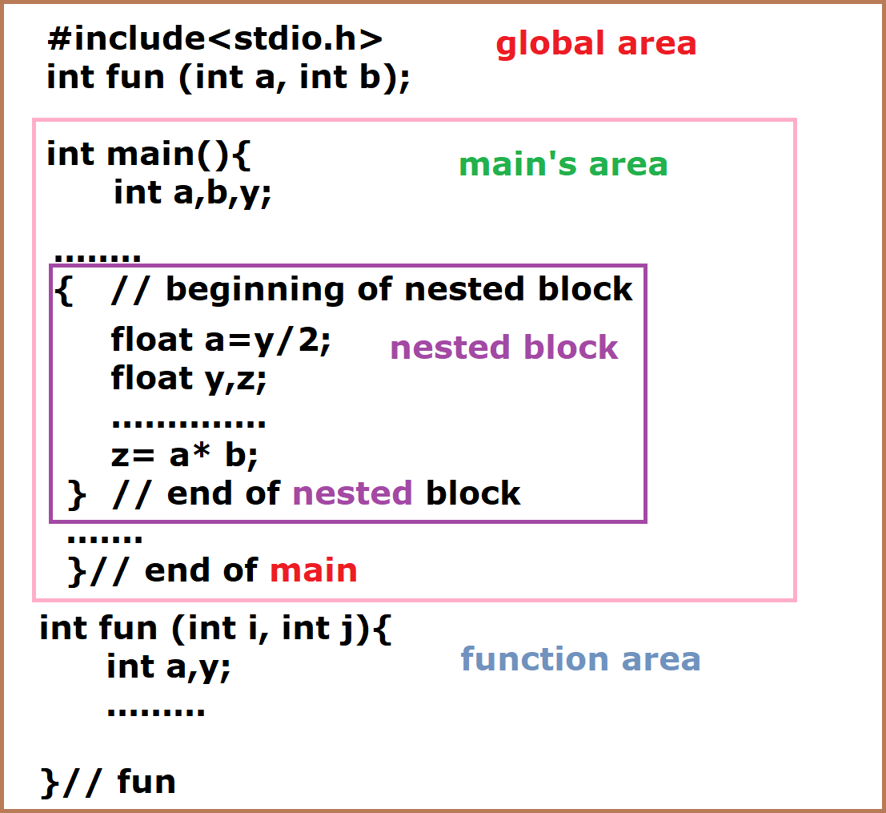

Storage classes and type qualifiers
- Storage classes specify the scope of the objects. Type qualifiers specify processing limitations on objects.
Storage classes
- There are only 4 storage class specifiers. They are auto, register, static and extern
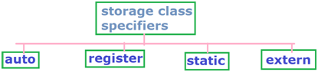
Auto variables
- A variable is declared inside a function without any storage class specification, is by default an automatic variable.
- An automatic variables can also called local variable, because they are local to a function
- By default they are assigned to the garbage value by the compiler.
- They are created when a function is called and or destroyed automatically when the function exists.
Syntax: storage class specification data type variable name;
Example: auto int x=10;
Program using auto variable
main() #include<stdio.h>
{ main()
int c; {
(or) auto int a=5,b=10;
auto int c; printf(“%d”,a);
} printf(“%d”,b);
}
Register variables
- The register storage class is used to define local variables that should be stored in register instead of RAM.
- A register access is much faster than a memory access keeping the frequently accessed variable in the resistor will lead to faster execution of programs.
Syntax: storage class data type variable name;
Example: register int count;
- Therefore only a few variables can be placed in the resistor.
Program using register variable
#include<stdio.h>
main()
{
register int i;
for(i=0;i<10;i++)
{
printf(“%2d”,i);
}
}
Output: 0 1 2 3 4 5 6 7 8 9
Static variables
- A variable is declared to be static by prefixing its normal declaration with keyword static.
Syntax: storage class data type variable name;
Example: static int a;
- Static variables can be declared within a function. These variables retain their values from pervious call i.e., the value that they had before returning from the function.
Program using static variable
sun()
main()
{
int i;
for(i=1;i<=3;i++)
{
sun();
}
}
sun()
{
static int x=0;
x=x+1;
printf(“%d”,x);
}
Output: 1 2 3
Explanation: Static variables are initialized only once when the program i compiled it never reinitialized the value.
Extern variable
- A variable that is defined outside of any function is a global variable. Global variables remain available throughout the entire program.
- The extern keyword is used before a variable to inform the compiler that this variable is declared somewhere else.
- The extern declaration does not allocate storage for variables.
Syntax: storage class data type variable name;
Example: extern int a;
Program using extern variable
#include<stdio.h>
int i;
main()
{
printf(“%d”,i);
}
Output: 0
Note: if you will not use extern keyword with global variable the compiler will automatically intiliase with default value 0.
#include<stdio.h>
extern int i;
main()
{
printf(“%d”,i);
}
Output: compilation error undefined symbol
Note: when we use extern modifier with any variable it is only declaration memory is not allocate for this variable. Hence compiler will show error message.
#include<stdio.h>
extern int i=10;
main()
{
printf(“%d”,i);
}
Output: 10
#include<stdio.h>
main()
{
extern int i=10;
printf(“%d”,i);
}
Note: we cannot initialize extern variable locally i.e within the block. We can only initialize extern variable globally.
Type Qualifier
- Type qualifier adds 3 special attributes to types:
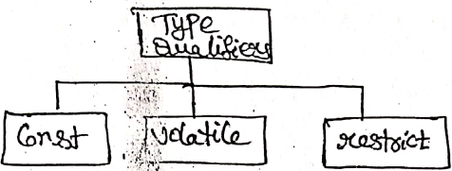
Const:
- Const refers to fixed values that do not change during the execution of the program.
- Constant object is a ready-only object i.e., cannot be modified.
- It is fixed value, it is also called literal.
Syntax: const data type variable name;
Example: const int a;
const float pi 3.14;
- Const is a keyword used to identify constant. Pointer can also be defined as constant.
Example: int a,b;
int *const ptr=&a;
ptr=&b;
Volatile:
- When a variable is defined as volatile, the program may not change the value of the variable explicitly.
- But these variable values keep on changing without any explicit assignment by the program. These types of qualifiers are called volatile.
Syntax: volatile data type variable name;
Example: volatile int x;
volatile int *ptr;
Restricted:
- The restricted qualifier, which is used only with the pointers indicates that the pointer is only the initial way to access the referenced data.
Example: int *ptr;
int a=0;
ptr =&a;
Structure of a C Program
Expressions
- An expression is a sequence of operands and operators that reduces to a single value.
- An expression can be simple or complex.
- Operands – 2,3,a.b,c etc
- Operators - +,-,<,>,*,=
- A Simple expression contains only one operator. For example, 2+5. and -a.
- A complex expression contains more than one operator. For example, 2+5*7.
- Simple expressions into 6 categories
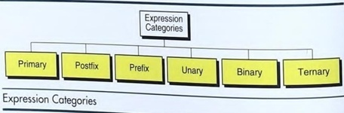
Primary Expressions
- A primary expression consists of only one operand with no operator.
- It can be a name, a constant, or a parenthesized expression.
Names
- A name is any identifier for a variable, a function or any other object in the language
- The following are the examples of some names used as primary expressions:

a b12 price calc INT_MAX SIZE
Literal constants
- A constant is a piece of data whose value can't change during the execution of the program.
- The following are examples of literal constants used in primary expressions.

5 3.14 'A' "Welcome"

Parenthetical expressions
- Any value enclosed in parentheses must be reducible to a single value and is therefore a primary expression.
- This includes any of the complex expressions when they are enclosed in parentheses. The following are the primary expressions:

(2 * 3 + 4) (a = 23 + b * 6)

Postfix expressions:
- The postfix expression consists of one operand followed by one operator.
- They are function call, postfix increment and postfix decrement.
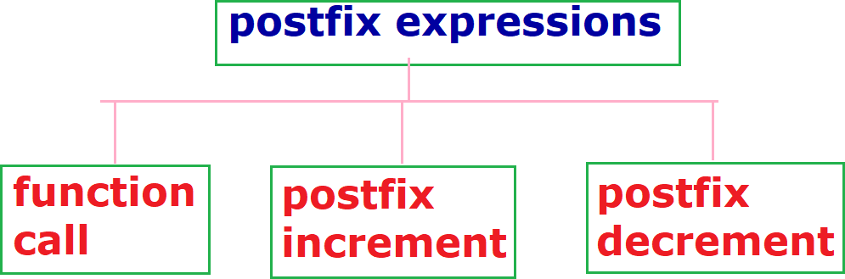
Function call
- Function calls are postfix expressions.
- The function name is the operand and the operators are the parentheses that follow the name. The parentheses may contain arguments or be empty.
Postfix increment/ decrement
- The post increment and postfix decrement are also postfix operators.
- In postfix increment, the variable is increased by 1. Thus a++ results in the variable a being increased by 1. The effect is the same as a=a+1.
- The major difference is the value of the postfix increment expression is determined before the variable is increased.
- For instance, if the variable a contains 4 before the expression is evaluated, the value of the expression a++ is 4.
Example:
#include <stdio.h>
int main (void)
{
int a;
printf("value of a : %2d\n", a);
printf("value of a++ : %2d\n", a++);
printf("new value of a: %2d\n\n", a);
return 0;
}
Results:
value of a: 4
value of a++: 4
new value of a: 5

Prefix Expressions
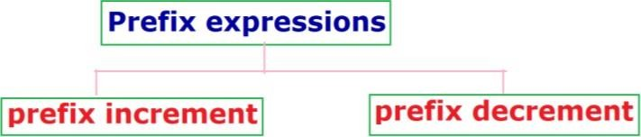
- It consists of the operator comes before the operand. They are prefix increment and prefix decrement.
Prefix increment/ decrement
- The prefix increment/decrement expression the prefix operators, effect takes place before the expression that contains the operator is evaluated. This is the reverse of the postfix operation.
#include <stdio.h>
int main (void)
{
int a = 4;
printf("value of a: “, a);
printf("value of ++a: ”, ++a);
printf("new value of a: “, a);
return 0;
}
Results:
value of a : 4
value of ++a: 5
new value of a: 5
Unary Expressions
- It is like a prefix expression; both consist of one operator and one operand.
- The prefix expression needs a variable as the operand while the unary expression can have an expression or a variable as the operand.
- They are the sizeof operator, the plus/minus operators, and the cast operator.
- The sizeof operator tells us the size, in bytes of type or a primary expression
sizeof (int)
Example:

sizeof -345.23 sizeof x
Unary Plus/Minus
- The unary plus and unary minus operators are the plus and minus signs.
- The plus operator does not change the value of the expression. If the expression’s value is negative, it remains negative; if the expression’s value is positive, it remains positive.
Example: +a -a
Cast Operator
- The cast operator converts one expression type to another. For example, to convert an integer to a real number, we would use the following unary expression.

(float) x

Binary Expressions

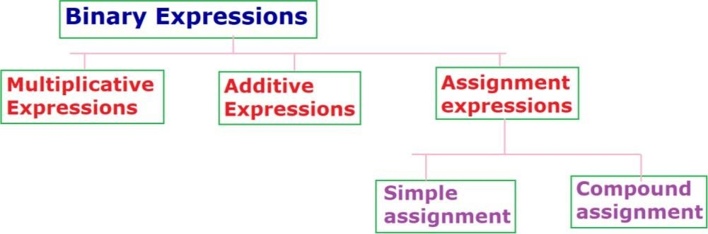
- Binary expressions are formed by an operand-operator-operand combination.
- Any two numbers added, subtracted, multiplied, or divided are usually formed in algebraic notation, which is a binary expression. There are many binary expressions.

Multiplicative Expressions
- The multiplicative binary expression include the multiply, divide, and modulus operators.
- The result of a multiply operator (*) is the product of the two operands.
- The operands can be any arithmetic type (integral or floating-point).
Example: 10 * 3 // evaluates to 30
'A' * 2 // evaluates to 130
22.3 * 2 // evaluates to 44.6
- The result of a divide operator (/) depends on the type of operands. If one or both operands is a floating-point type, the result is a floating-point quotient.
- If both operands are integral type, the result is the integral part of the quotient.
Example: 10 / 3 // evaluates to 1
'A' / 2 // evaluates to 5
22.3 / 2 // evaluates to 11.5
- Modulo operator divides the first operand by the second and returns the remainder rather than the quotient.
- Both operands must be integral types and the operator returns the remainder as an integer type.
Example: 10 % 3 // evaluates to 1
‘A’ % 10 // evaluates to 5
22.3 % 2 // error: Modulo cannot be floating-point

Additive Expressions
- In additive expressions, the second operand is added to or subtracted from the first operand, depending on the operator used.
- The operands in an additive expression can be any arithmetic types (integral or floating - point).
- Additive operators have lower precedence than multiplicative operators.
Example: 3 + 7 // evaluates to 10
3 - 7 // evaluates to -4
Assignment Expressions
- The assignment expression evaluates the operand on the right side of the operator (=) and places its value in the variable on the left.
- There are two forms of assignment: simple and compound
Simple Assignment
- Simple assignment is found in algebraic expressions. The following are three examples of simple assignments are:

a = 5 b = x + l i = i + 1
- The left variable must not be a constant.
Compound Assignment
- A compound assignment is a shorthand notation for a simple assignment.
- It requires that the left operand as a part of the right expression. Compound assignment operators are *=, /=, % =, +=, and -=.
- To evaluate a compound assignment expression, first change it to a simple assignment, as shown below:
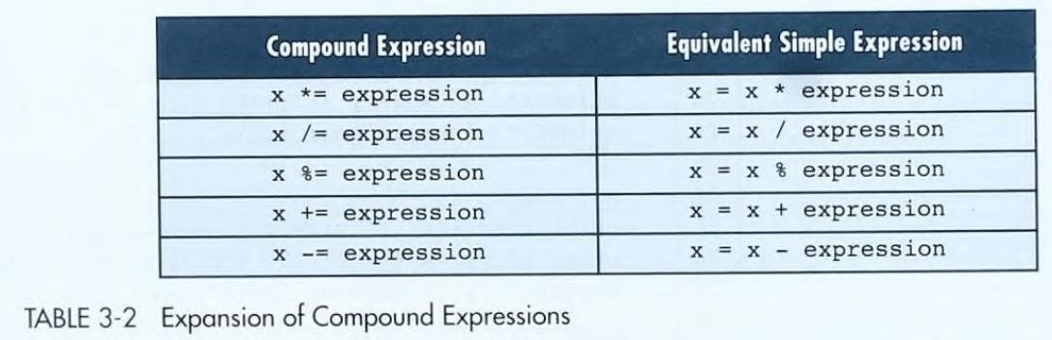
- When a compound assignment is used with an expression, the expression is evaluated first.
Thus, the expression x *= y + 3
is evaluated as x= x * (y + 3)
which, given the values x is 10 and y is 5. evaluates to 80.
Precedence and Associativity
- Precedence is used to determine the order in which different operators in a complex expression are evaluated.
- Associativity is used to determine the order in which operators with the same precedence are evaluated in a complex expression.
Precedence
- If more than one operator is involved in an expression then, c language has predefined rule of priority of operators. This rule of priority of operators is called operators precedence.
+,- - first priority
*,/,% - second priority
Rules:
- Two arithmetic operator symbols must never be placed side by side.
5*%6 (invalid expression)
- Parenthesizes may be used to form grouping and all expressions enclosed within parenthesis are evaluated first.
(6+4)/(2+3) = 10/5 = 2
- Set of parenthesis may also be ended by other parenthesis
(2+(3*4)) =(2+12) = 14
Program on precedence on an expression
#include <stdio.h>
main ()
{
int a = 4,b=20,c=30;
printf("a*b+c is %d\n: “, a*b+c);
printf("a*(b+c) is %d\n: “, a*(b+c));
}
Output:
a*b+c is 230
a*(b+c) is 500
Associativity
- Associativity is used only when the operators all have the same precedence. Associativity can be left-to-right or right-to-left.
Left-to-right Associativity
- Left-to-right associativity evaluates the expression by starting on the left and moving to the right.
- The following shows an example of left-to-right associativity. Here we have four operators of the same precedence (* / % *).
3 * 8 / 4 % 4 * 5
- All of these operators have the same precedence (13). Their associativity is from left to right. So, they are grouped as follows:
((((3 * 8) / 4) % 4) * 5)
- The value of this expression is 10. A graphical representation of this expression is shown in Figure.
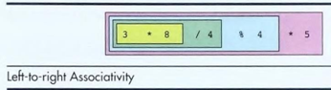
Right-to-left Associativity
- Right-to-left associativity evaluates the expression by proceeding from the right to the left.
- When more than one assignment operator occurs in an assignment expression, the assignment operators must he interpreted from right to left.
- This means that the rightmost expression will be evaluated first; then its value will he assigned to the operand on the left of the assignment operator and the next expression will be evaluated.

Example a += b *= c -= 5
is evaluated as (a += (b *= (c -= 5)))
which is expanded to (a = a + (b = b * (c = c - 5)))
- If a has an initial value of 3, b has an initial value of 5, and c has an initial value of 8, these expressions become (a = 3 + (b = (5 * (c = 8 - 5))) which results in c being assigned a value of 3, b being assigned a value of 15, and a being assigned a value of 18. The value of the complete expression is also 18.
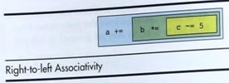
- Several operators have right-to-left associativity as shown in the precedence table
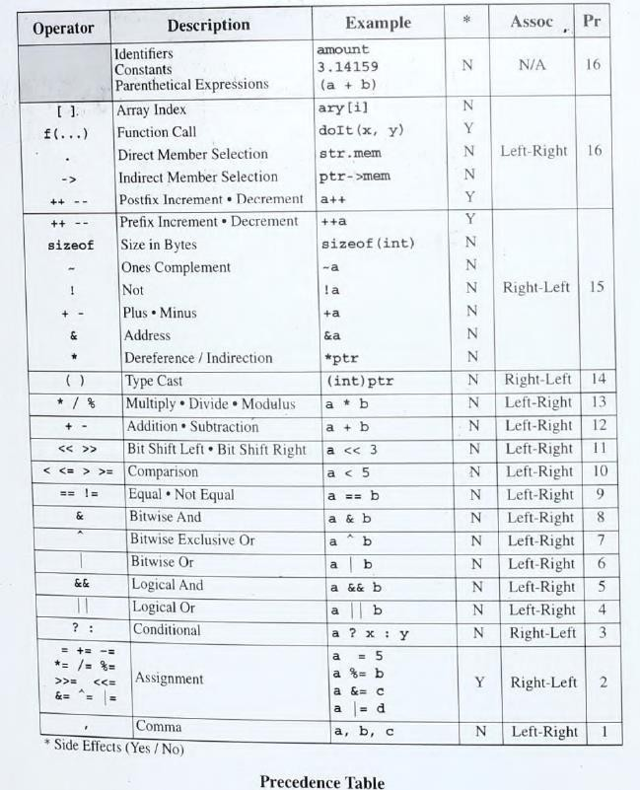
Type Conversion
- Type converse on can be defined as converting one data type into another data type.
- There are 2 different type conversions are there they are:
- Automatic or implicit type conversion.
- Type casting or explicit type conversion.
Implicit Type Conversion
- When the type conversion is performed automatically by the compiler without programmer intervention such type of conversion is known as implicit type conversion.
- If operators are different types the lower type is automatically converted to higher type before operation proceed.
- The following Figure shows the ranks as we use them for conversion.
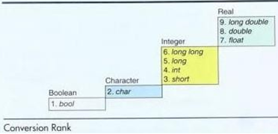
- There are two types of conversions in implicit type conversion as:
- Assignment Type Conversion
- Automatic Type Conversion
Assignment Type Conversion
- This means that the value of the expression on the right side of the equal sign is converted to the data type of the variable to the left of the equal sign.
Example: result = 4;
- When ‘result’ is declared as double ‘4’ is an integer then ‘4’ will be converted to the double Precision value 4.0 and the value is assigned to the result.
Automatic Type Conversion
- The data type have lower rank is converted automatically in to higher rank data before the operation process.
- This automatic conversion across an assignment operator is referred to as integer type conversion
Example program for implicit type conversion
#include <stdio.h>
int main ()
{
double a = 2.5,s;
int b=2;
s=a+b;
printf("value of s = %d “, s);
}
Output:
value of s = 4

Explicit Type Conversion/Type Casting
- Type conversion performed by the programmer to change the data type of the expression of a specific type is known as explicit type conversion.
Syntax: (data type) expression
Example: double sum/count;
Example program for explicit type conversion
#include <stdio.h>
int main ()
{
int sum=17,count=5;
double mean;
mean=(double)sum/count;
printf("value of mean = %f “, mean);
}
Output:
value of mean = 3.400000
Command Line Arguments
- The function main can be defined either with no argument or with two arguments.
- First argument is the number of command line arguments.
- Second is list of command line argument.
main ( ) int main(int arg,char *argv[])
{ {
….. …..
} }
Without command line argument with command line argument
argc(argument count)
- It is int it stores number command line arguments passed by the user including the name of the program.
- If we pass a value to a program, value of argc would be 2 (one for argument and one for program name).
- The value argc should be non negative.
argv(argument vector)
- It is an array of characters pointer listing all the arguments.
- The value of argc is determined from the user typed values for argv’s.

Program using command line argument
#include <stdio.h>
#include <stdlib.h>
int main (int argc,char argv*[ ])
{
printf("The number of arguments:%d\n“, argc);
printf("The name of the program:%s\n“, argv[0]);
for(int i=1;i<argc;i++)
printf("User value number %d : %s\n“, i,argv[i]);
return 0;
}
Output:
c:>cmdline
The number of arguments:1
The name of the program: CMDLINE
c:>cmdline hello
The number of arguments:2
The name of the program: CMDLINE
User value number 1: hello
c:>cmdline Now what is the time
The number of arguments:6
The name of the program: CMDLINE
User value number 1: Now
User value number 2: what
User value number 3: is
User value number 4: the
User value number 5: time

Assignment questions

- What is scope? explain storage classes and type quantifiers in detail.
- What is command line arguments? Explain them with an example program.
- What are the steps involved in program development process? Explain.
- What is type conversion? Explain different types of type conversions with an example program.
- What is associativity and operator precedence? Explain them with an example program.
- Write neat discussion about input and output statements in C programming.
- Explain the following
a) Computer Systems b) Computing Environments c) Computer languages
- Explain computer numbering systems?
- Explain the following
a) Storing integers b) storing real numbers
- Explain the following
a) C background b) identifiers c) types d) constants 5) keywords

IMPORTANT QUESTIONS FROM PREVOIUS QUESTION PAPERS

- What is the difference between low level and high-level language and uses of them?
- Define system software and application software and give examples for each one.
- Why is the C language called as middle level language?
- What is the difference between procedural language and object-oriented language?
- Differentiate between Random Access Memory and Read Only Memory.
- Define Assembly language.

7 Marks Questions:
- What are the steps involved in program development process? Explain.
- What is Central Processing Unit (CPU) in a computer? Explain about various components and their functions of CPU.
- Distinguish between machine, assembly, low-level and high-level languages.
- Discuss the features and characteristics of application software and system software.
- Discuss about different computer languages with examples.
- What are the components of computer? Explain.

